Screenshots of the output obtained

- Import the necessary libraries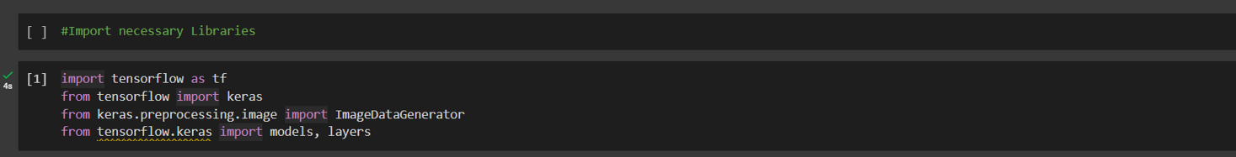
- Data pre-processing of the images
- Fetch the training set of images along with their associated one-hot encoded labels
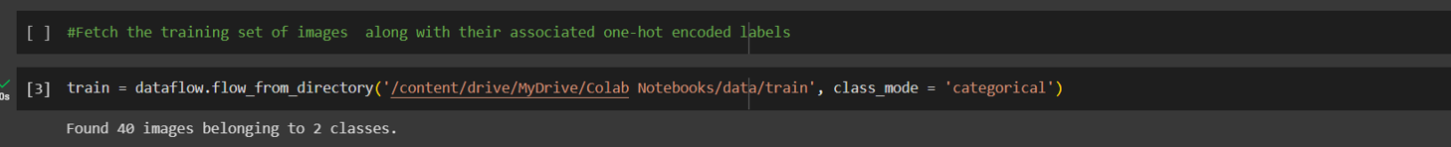
- Fetch the testing set of images along with their associated one-hot encoded labels
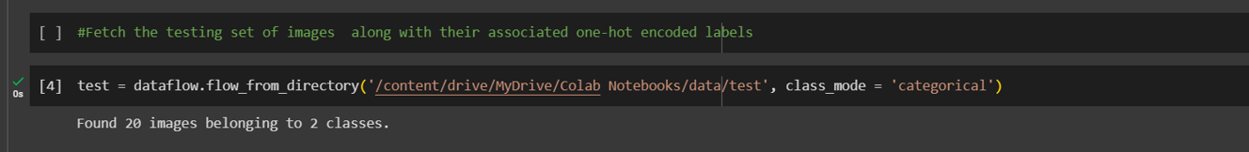
- The CNN model would have the following layers:
● Input layer
● Convolutional layer 1 with 32 filters of kernel size[5,5]
● Pooling layer 1 with pool size[2,2] and stride 2
● Convolutional layer 2 with 64 filters of kernel size[5,5]
● Pooling layer 2 with pool size[2,2] and stride 2
● Dense layer whose output size is fixed in the hyper parameter: fc_size=32
● Dropout layer with dropout probability 0.4
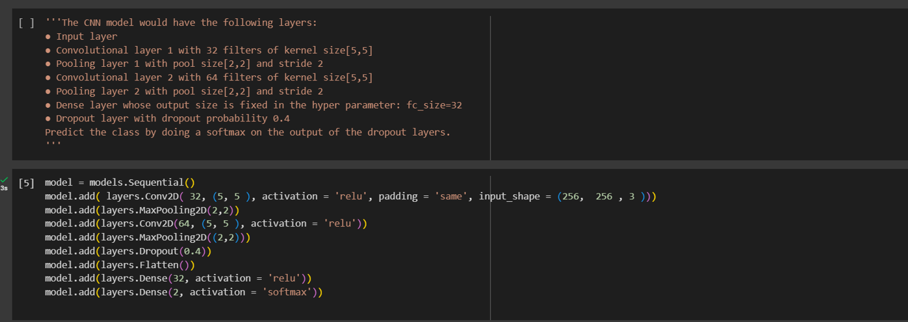
- SGD Optimizer with learning rate 0.001 is used to define and the loss function
- Compling the model
- Model training for 100 iterations
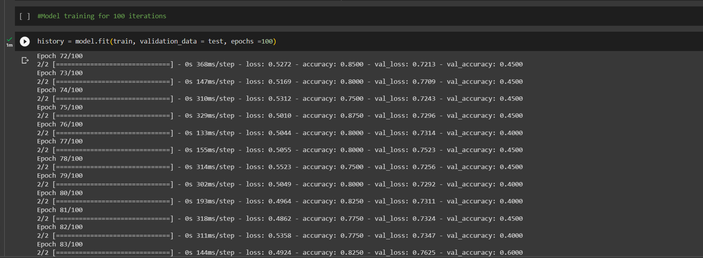
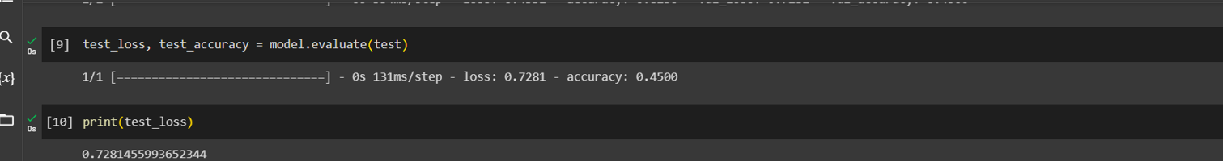
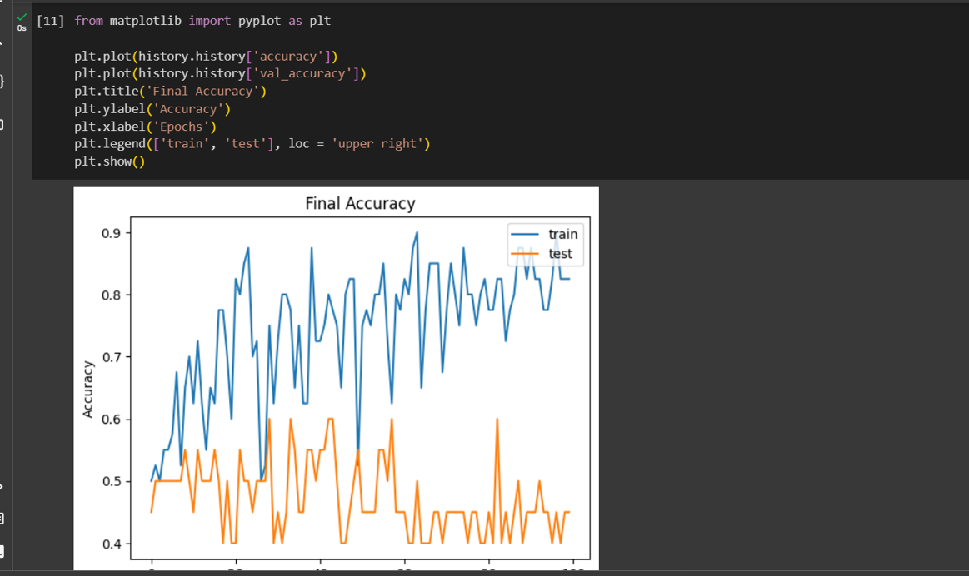
- Model training for 200 iterations
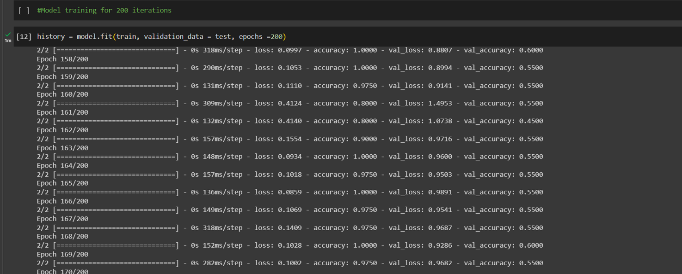
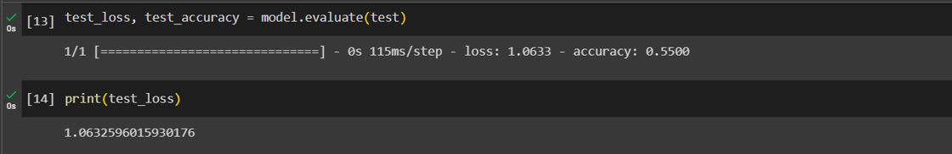
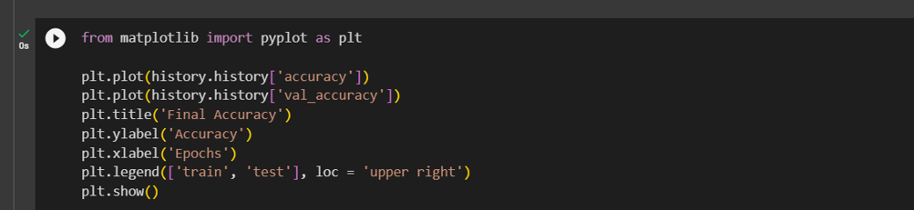
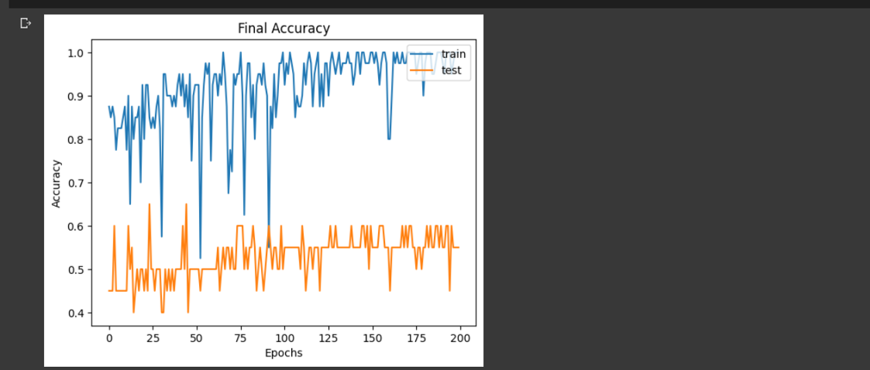
- Model training for 300 iterations
